Functional Decomposition of Castillo De Luna’s Systems Architecture in a Top-Down Inverted Tree Representation.

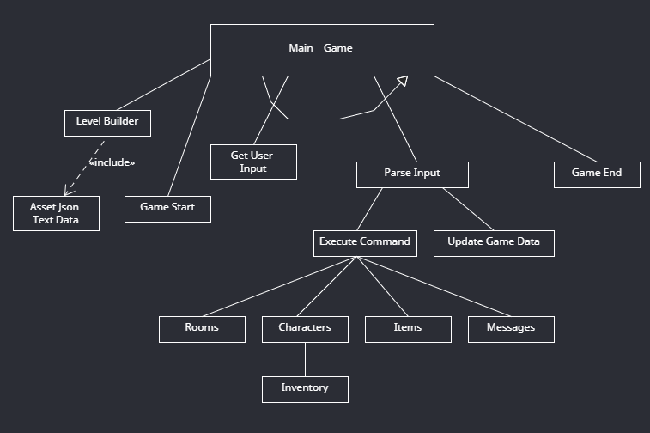

Main Game: Begins by building the level in the level builder, start the game with the header and beginning messages, start the game loop controlled by the current game state (alive or dead) and getting the input from the user, parse the input, do the actions and keep looping until the state has changed. The game end functionality is the last to happen before the game closes.

Level Builder: Gets the data from Asset JSON Text Data to build level objects.

Game Start: Displays the game header, welcome messages, and gives the user an option to play or quit.

Get User Input: Gets the user input provided by the user to prompted messages from the game.

Parse Input: Analyse the user input and send it to be executed or send back to user for retry.

Execute Command: Executes the actions on Rooms, Characters, Items and Messages.

Update Game Data: Updates the game data according to the input and Execute Command data.

Game End: Displays the end game messages and ends the game.